Prompt Engineering Assignment 2 Answers
Richard Hurley
Part 1:
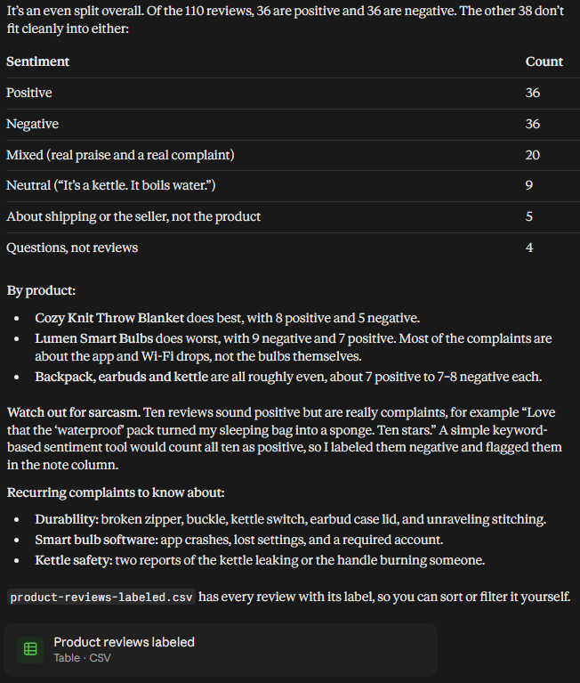
Looking at this compared to the CSV file, it sorted them better than I expected, Claude even gave me a csv file back which really shocked me since I didn’t ask for it. It hand;ed the confusing reviews well giving them their own neutral / mixed categories, it even caught reviews that were not really reviews and were just questions.

Part 2:
Prompt given: Label every review in this file as positive, negative, or mixed, positive means the customer is happy overall, negative means they are unhappy overall, and mixed means they praise something but also complain about something. Give me the results in a table with the columns Review ID, Product, Label, and Reason so I can paste it into a spreadsheet.
(define the categories technique: added the part of positive, negative, or mixed)
(output format technique: said to give me a table)
Response:
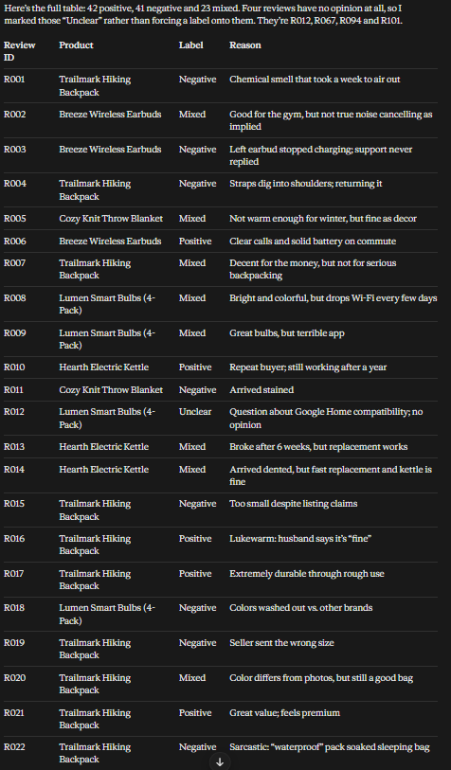
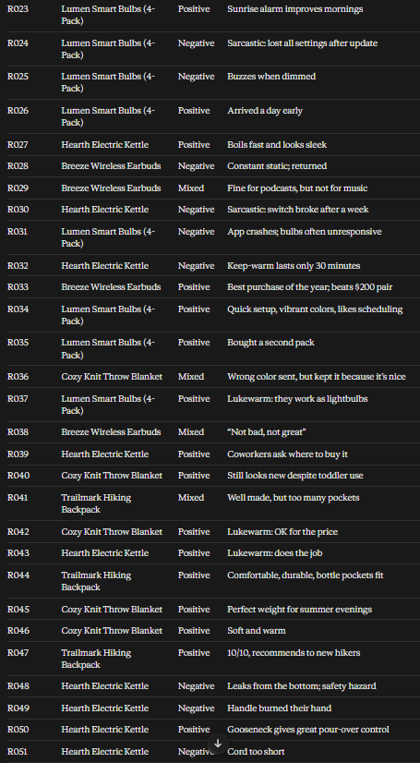
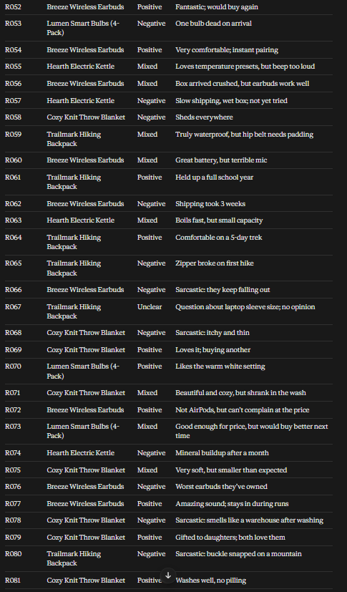
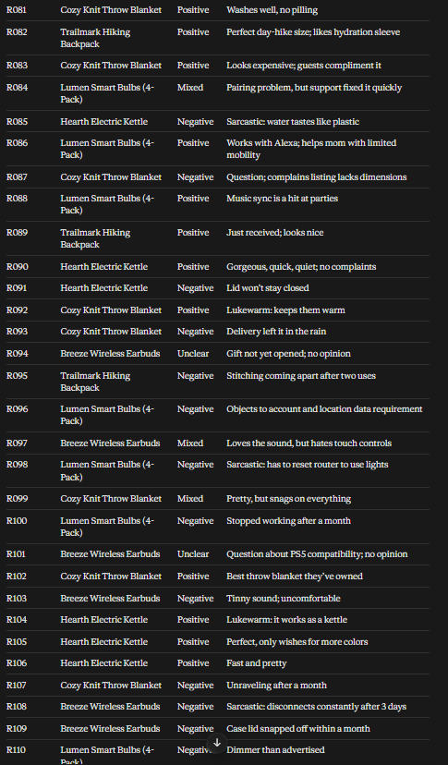
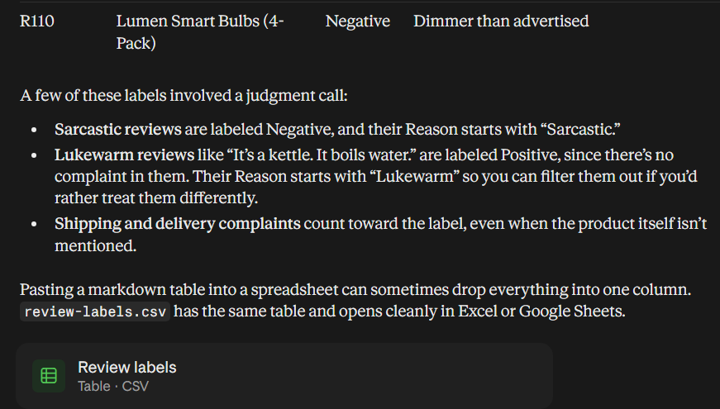

So I definitely messed up by not specifically a table in csv only, so it printed it out all out text, but it did label them all the reviews only negative, positive, and mixed which is what I asked. It is in a copy pastable format so I can put it in a spread sheet, and has all the columns that I wanted, Review ID, product, label, and reason. Overall this was more bloated(that was my fault) than the first response but similarly it gave me a table, with sorted responses, this response was just more sorted than the last one, that was the big difference.

Part 3:

My products / labels:
R009, Lumen Smart Bulbs (4-Pack): Mixed
R012, Lumen Smart Bulbs (4-Pack): Unclear
R014, Hearth Electric Kettle: Mixed
R022, Trailmark Hiking Backpack: Negative
R030, Hearth Electric Kettle: Negative
R033, Breeze Wireless Earbuds: Positive
R048, Hearth Electric Kettle: Negative
R060, Breeze Wireless Earbuds: Mixed
R072, Breeze Wireless Earbuds: Positive
R094, Breeze Wireless Earbuds: Unclear

I surprisingly agreed with Claude on the 10 reviews I picked and labeled. Even without me specifically calling out the sarcasm or warning that some of the responses could be misleading, it caught them, for example on R022 and R030, the customer pretended to be happy with the product but wasn't. Claude again gave me an unclear label even though I never told it too, and I picked out some unclear reviews just to see what would happen, and it caught them and didn;t try to guess the label but left them as unsure, like for R094.

